Directions & Meeting Agenda – 5/2/16

Directions – Parking at UCSD

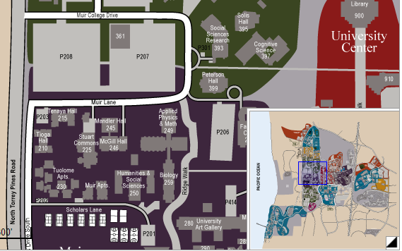

**1**

**2**

**3**

1. We’ll be meeting in UCSD’s Muir College, on the west side of campus. The street you will reach it from is North Torrey Pines Road.
2. You can enter through Muir College Drive. The parking lot is paid, so one of us will meet you at the lot, and will be more than happy to purchase the required pass.
3. We’ll have our meeting in a conference room at the Cognitive Science Building in Muir College.
4. For more details, check out <http://en.parkopedia.com/parking/lot/uc_san_diego_john_muir_college_lot_p208/92037/san_diego/>

Meeting Agenda

* Goals: